REPORT ASSIGNMENT AML-3

INTRODUCTION:

The report has a detailed explanation by taking the cats and dogs example which explains the relation between the training sample size and choice of network architecture.

And also in this report we will be using the techniques to reduce overfitting and improve performance

And this also evauluates the performance on a validation and test set.

After that, we are going to compare the results which we got using a network which is trained from scratch and pretrained network.

Training network from scratch.

* We start with the training sample of 1000, validation sample of 500, and a test sample of 500
* And we used a CNN with the three convolutional layers two max pooling layers, and 2 dense layers.
* After that to reduce the overfitting we have applied droup out after second dense layer.
* After that we got the initial accuracy which is 74.8% but this Was happened due to overfitting
* Later there we introduced the data augmentation, early stopping and drop out, which caused the accuracy to drop.
* When these techniques are been introduced the accuracy just was dropped, but this is expected as the model is now going to get better generalized and less prone to over fitting

Displaying curves of loss and accuracy during training

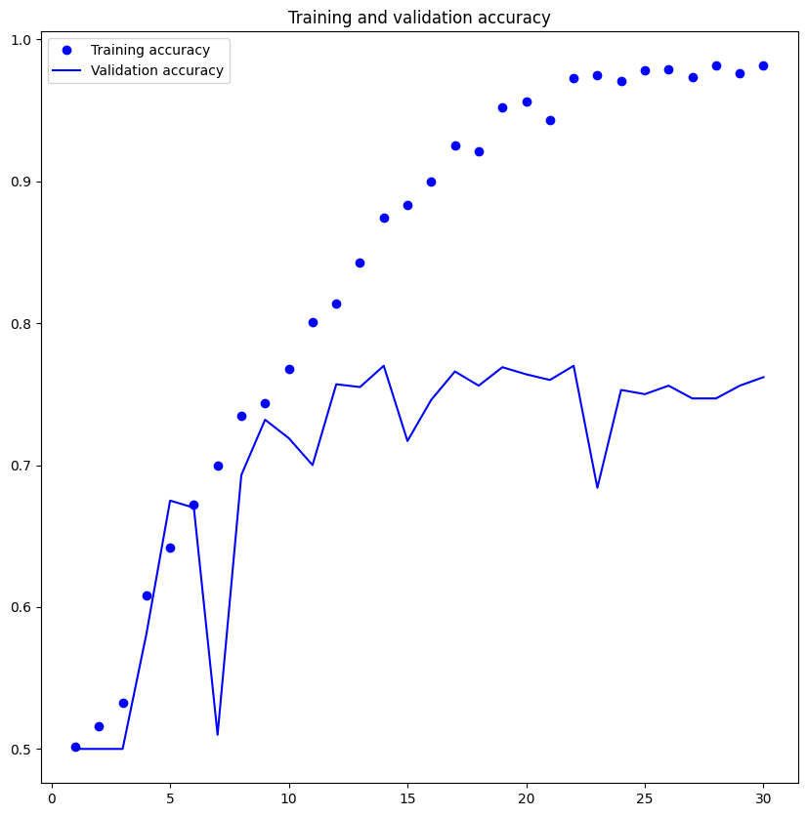

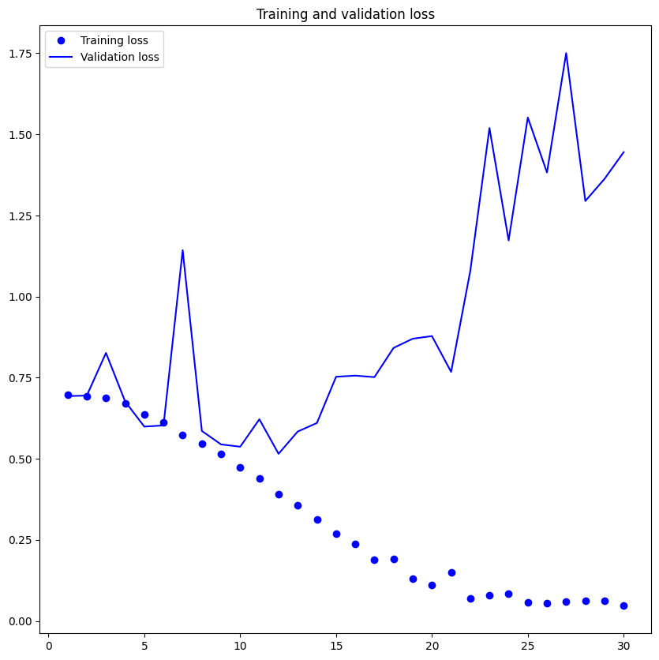

* Using a pretrained network:

Getting high accuracy while devoloping a deep learning model from start can be hard especially when dealing with a limited dataset One solution is to employ a pretrained model that has already learnt key features on a big dataset and finetune it for your unique objective By doing so you may use the information that the pretrained model has gained and apply it to your task perhaps yielding better results than beginning from 0

You utilized a pretrained VGG16 network a common deep learning architecture that was already trained on a big dataset in your case You froze the convolutional layer weights and added a dense layer with 256 units before finetuning the model on your dataset As a consequence your validation accuracy was 97.6% which is a huge increase over establshing a model from scratch This method emphasizes the advantages of employing pretrained models and finetuning them for your unique goal

Pretrained model with augmentation: Here the validation accuracy slightly increased to 97.3%. Using predefined model with fine tuning gave 97.8% test accuracy.

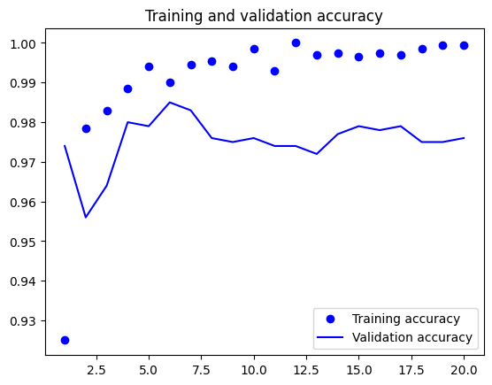

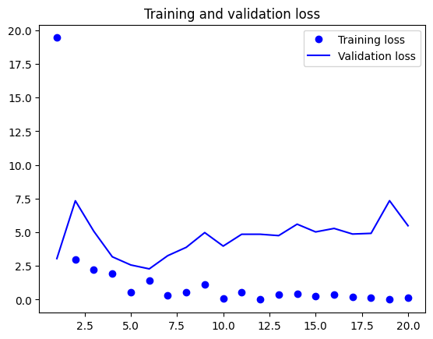

Table:

Table for trained model analysis

|  |  |  |  |
| --- | --- | --- | --- |
| Loss values | Accuracy values | Validation loss | Validation accuracy |
| 0.0472 | 0.9815 | 1.4452 | 0.7620 |

After increasing training sample and pretrained sample

|  |  |  |  |
| --- | --- | --- | --- |
| Loss values | Accuracy values | Validation loss | Validation accuracy |
| 0.6299 | 0.9895 | 2.1986 | 0.9810 |

Conclusion:

Certainly  Our research found that the quantity of the training dataset and the network architecture used had a significant influence on the performance of deep learning models We discovered that extending the training sample size and employing a pretrained network may significantly increase performance Furthermore we observed that the link between training sample size and network design selection is complex Simpler structure of networks may serve for smaller datasets whilst bigger datasets might require more complicated structures to capture the underlying patterns in the data